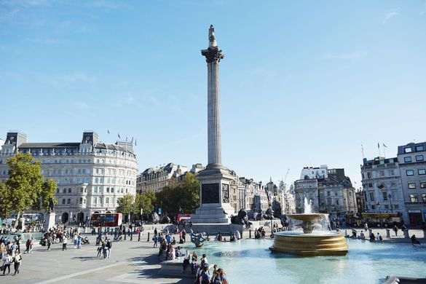
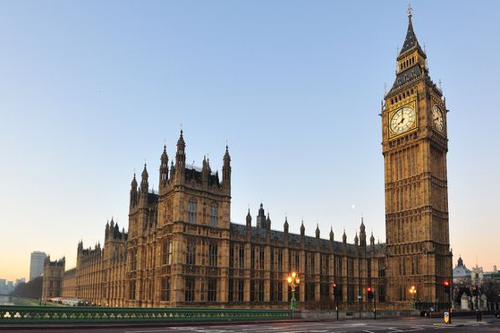
Welcome to London !

- This is a map of a part of London
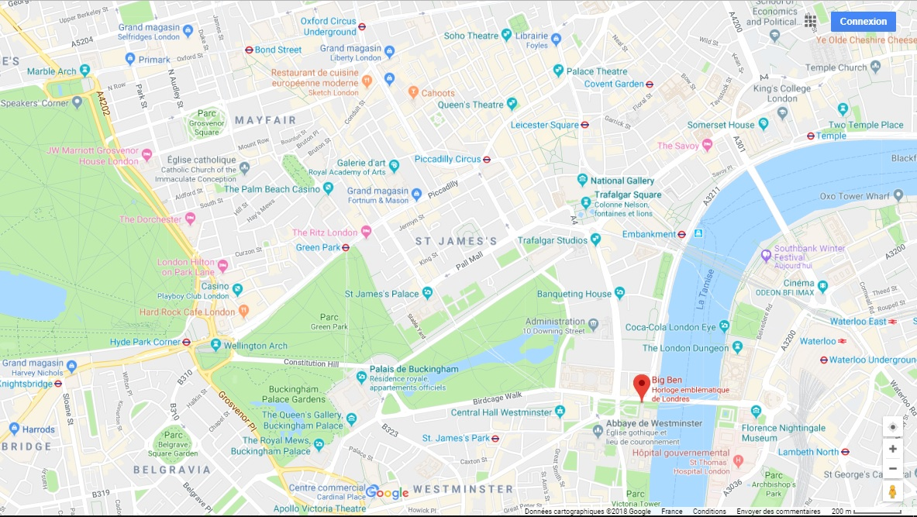
3
10
11
13
12
9
8
1
5
7
6
4
2
11

- Associate the numbers with the names of these famous monuments.
1 |  | 8
2 |  | 9
3 |  | 10
4 |  | 11
5 |  | 12
6 |  | 13
7

- Give directions… (on your notebook)
a) How do you get from The London Eye to Big Ben?
b) How do you get from the Marble Arch to Piccadilly Circus?
c) How do you get from Buckingham Palace to Covent Garden?
d) How do you get from Harrod’s to Westminster Abbey?

