# EXERCISES / ANSWERS

**1.** Add **–ing** to these verbs. [Πρόσθεσε την κατάληξη **–ing** σ’αυτά τα ρήματα.]

**1**. talk  **talking 8.** love loving

**2**. choose **choosing 9.** dance dancing

**3.** clap clapping 1**0.** write writing

**4.** stop stopping **11.** play playing

**5.** hide hiding **12.** take taking

**6.** put putting **13.** begin beginning

**7.** sing singing **14.** study studying

**2.** Write, as in the example. [Γράψε, όπως στο παράδειγμα.]

1. **She is** phoning her mother now.  **She’s**  phoning her mother now.

2. **He is** leaving now. __He’s__ leaving now.

3. **They are** cutting the grass. __They’re__ cutting the grass.

4. **It is** drinking milk. _ It’s_____ drinking milk.

5. **We are** staying at our grandma’s. ___We’re __ staying at our grandma’s.

6. **You are** playing with my ball. ___You’re playing with my ball.

**3.** Write the **present progressive** form of the verbs. [Βάλε τον **ενεστώτα διαρκείας** των ρημάτων]

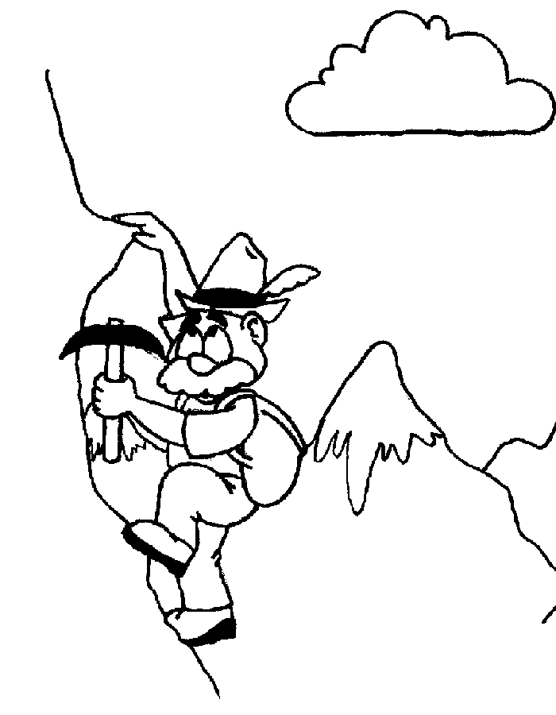  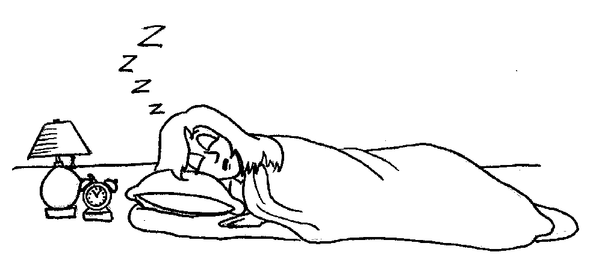

He / climb He / dance She / sleep

**1** He’s climbing **2** He’s dancing  **3 She’s sleeping**

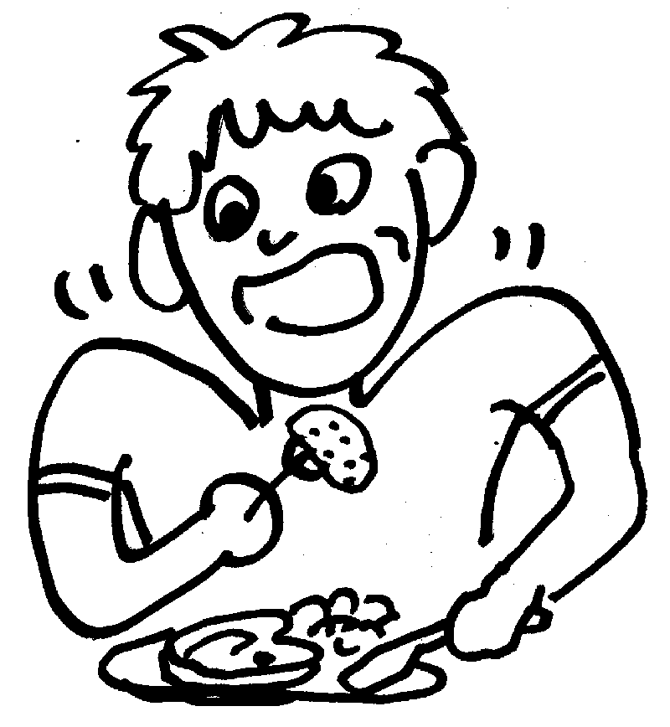 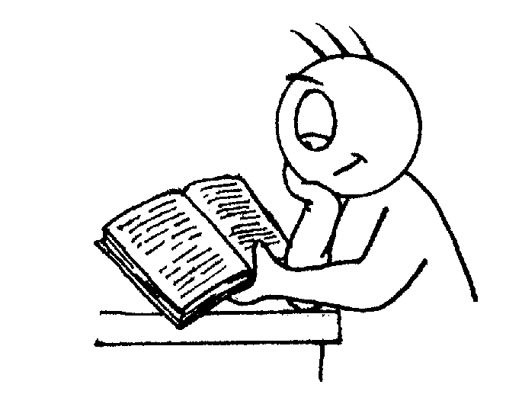 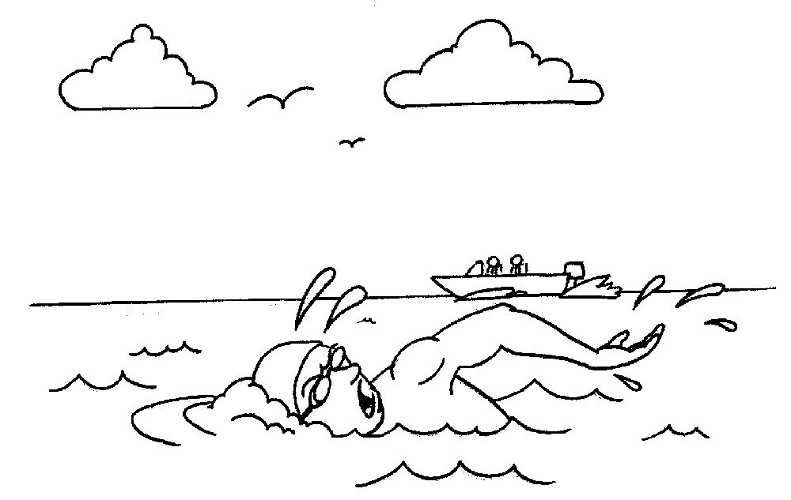

### He / eat He / read He/ swim

**4** He’s eating  **5 He’s reading** **6 He’s swimming**