Name
GEOGRAPHY TEST

- Write the names of the countries in the box, and the capital cities on the line.
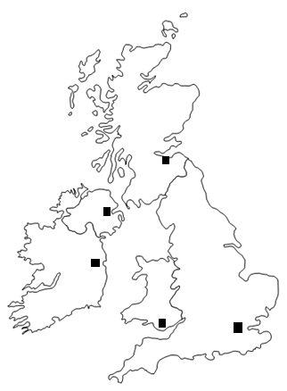

- Complete the grid:
 | 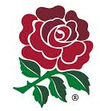 |  | 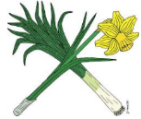 | 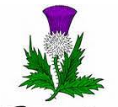
NAME OF THE SYMBOL
COUNTRY
NATIONALITY

- Complete :

GREAT-BRITAIN = ________________+ _______________+ ______________

The UNITED-KINGDOM = _____________________+ _____________________

The United Kingdom is governed by……………………………………………………………………….

