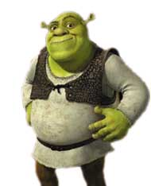

A. Shrek needs to match the numbers to their names. Help him!

1 2 3 4
5 6 7 8
9 10 11 12

B. Donkey starts to count strangely. Find the mixed up numbers
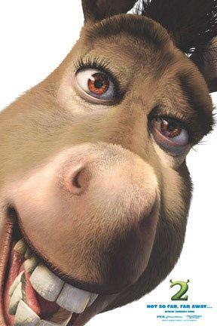
hetre …………… vfie ………………… neelve …………
neo ……………… owt …………………ixs ………………
inen ……………… oufr …………………ghite ……………
veesn ……………… wetvel ………………nte ………………

2 + 2 = four
Am I smart, or what???
C. Shrek needs to write the correct answer in words. Help him.
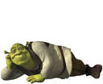
1) 3 + 2 = …………………… 2) 7 + 3 = ………………………
3) 10 + 2 = ………………… 4) 5 + 2 = ………………………
5) 3 + 8 = …………………… 6) 3 + 3 = ………………………
7) 2 + 7 = …………………… 8) 4 + 1 = ………………………

D. Puss in boots is confused. All the numbers' words got lost in the word search. Find them.
Numbers… numbers… Psss…. where are you?
S | E | V | E | N | T | T | G
T | F | F | I | E | W | E | T
W | I | O | G | T | O | N | E
E | V | U | H | H | W | I | S
L | E | R | T | R | F | N | I
V | N | V | E | E | S | E | X
E | L | E | V | E | N | F | W
Where is Shrek? I need his brain…
E. Fiona tries to solve this crossword, but she needs help.

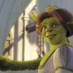
7
11

2
6
 |  |  |  |  |  |  |  |  | 12
12
3
HAVE |  |  |  |  |  |  |  |  |  | 8
9 |  |  |  |  |  |  |  |  |  | 4
FUN!
1
 |  |  |  |  |  |  | 10
5

